Comprehensive Effects of Alcohol Questionnaire
(Fromme et al., 2003)

INSTRUCTIONS: Please read the list of endings to the sentence “If I were under the influence from drinking alcohol…” and tell us how strongly you agree/disagree with these statements. Mark your answers on the scantron form using the following scale:

A= Disagree B= Mostly Disagree C= Mostly Agree D=Agree

If I were under the influence from drinking alcohol…
- I would act sociable.
- I would be loud, boisterous or noisy.
- I would feel powerful.
- My head would feel fuzzy.
- It would be easier to talk to people.
- I would feel shaky or jittery the next day.
- It would be easier to express feelings.
- I would feel energetic.
- My writing would be impaired.
- My body would feel relaxed.
- I would feel brave and daring.
- I would feel sexy.
- I would fee unafraid.
- I would feel creative.
- I would be talkative.
- I would enjoy sex more.
- I would be humorous.
- It would be easier to act out my fantasies.
- I would be clumsy.
- I would feel courageous.
- I would feel dizzy.
- I would be outgoing.
- I would feel peaceful.
- I would have difficulty thinking.
- I would feel energetic.
- My senses would be dulled.
- I would be friendly.
- I would neglect my obligations.
- I would take risks.
- I would be a better lover.
- I would act aggressively.
- My responses would be slowed.
- I would act tough.
- I would feel moody.
- I would feel guilty.
- I would feel dominant.
- I would feel self-critical.
- I would feel calm.
- My problems would seem worse.
Drinking Expectancy Questionnaire – 5 Factor Version
(Lee et al., 2003)

The following pages contain a series of statements about how people might think, feel, or
behave. Please read each statement carefully and indicate how much you agree with it. Use the 5-points scale below and enter your answers on the scantron. Make sure the answer on the scantron corresponds to the correct item from the survey. There are no right or wrong answers. Just give the answer that is most accurate for you.
Remember, your responses are anonymous, so please be completely honest.

A B C D E
Definitely Mostly Neither Agree Mostly Definitely
Disagree Disagree or Disagree Agree Agree

- Drinking alcohol makes me tense
- I am clumsier when drinking alcohol
- I am more aware of what I say and do if I’m drinking
- Drinking makes the future brighter
- I drink alcohol because it’s a habit
- Drinking makes me more sexually responsive
- Drinking makes me bad tempered
- I am less concerned about my actions when I’m drinking
- I tend to avoid sex if I’ve been drinking
- I feel that drinking hinders me in getting along with other people.
- I feel restless when drinking alcohol
- Drinking alcohol sharpens my mind
- I am more sullen and depressed when drinking alcohol
- If I’m drinking, it’s easier to express my feelings
- I cannot always control my drinking
- Drinking increases my aggressiveness
- When I am anxious or tense I do not feel the need for alcohol.
- Drinking alcohol removes most thoughts of sex from my mind
- Drinking does not help to relieve any tension I feel about recent concerns and interests.
- Drinking makes me feel like a failure
- I am addicted to alcohol
- Drinking makes me feel outgoing and friendly
- Drinking brings out the worst in me
- Drinking makes me feel more violent
- Little things annoy me less when I’m drinking
- I lose most feelings of sexual interest after I have been drinking
- Drinking helps me to be more mentally alert
- I have more self-confidence when drinking
- I am powerless in the face of alcohol
- When I’m drinking, I avoid other people or situations for fear of embarrassment
- I feel disappointed in myself when drinking
- I do not need alcohol to help me unwind after a hard day or week at work.

PSS

The questions in this scale ask you about your feelings and thoughts during the last month. In each case, you will be asked to indicate how often you felt or thought a certain way. Although some of the questions are similar, there are differences between them and you should treat each one as a separate question. The best approach is to answer each question fairly quickly. That is, don't try to count up the number of times you felt
a particular way, but rather indicate the alternative that seems like a reasonable estimate.

Please use the following scale and indicate your answers on the scantron form.

A = Never B= Almost Never C= Sometimes D=Fairly Often E = Very Often

72. In the last month, how often have you been upset because of something that happened unexpectedly?
73. In the last month, how often have you felt that you were unable to control the important things in your life?
74. In the last month, how often have you felt nervous and "stressed"?
75. In the last month, how often have you dealt successfully with irritating life hassles?
76. In the last month, how often have you felt that you were effectively coping with important changes that were occurring in your life?
77. In the last month, how often have you felt confident about your ability to handle your personal problems?
78. In the last month, how often have you felt that things were going your way?
79. In the last month, how often have you found that you could not cope with all the things that you had to do?
80. In the last month, how often have you been able to control irritations in your life?
81. In the last month, how often have you felt that you were on top of things?
82. In the last month, how often have you been angered because of things that happened that were outside of your control?
83. In the last month, how often have you found yourself thinking about things that you have to accomplish?
84. In the last month, how often have you been able to control the way you spend your time?
85. In the last month, how often have you felt difficulties were piling up so high that you could not overcome them?

Derived from: Cohen et al. (1983). A global measure of perceived stress. Journal of Health and Social Behavior, 24: 385-396.
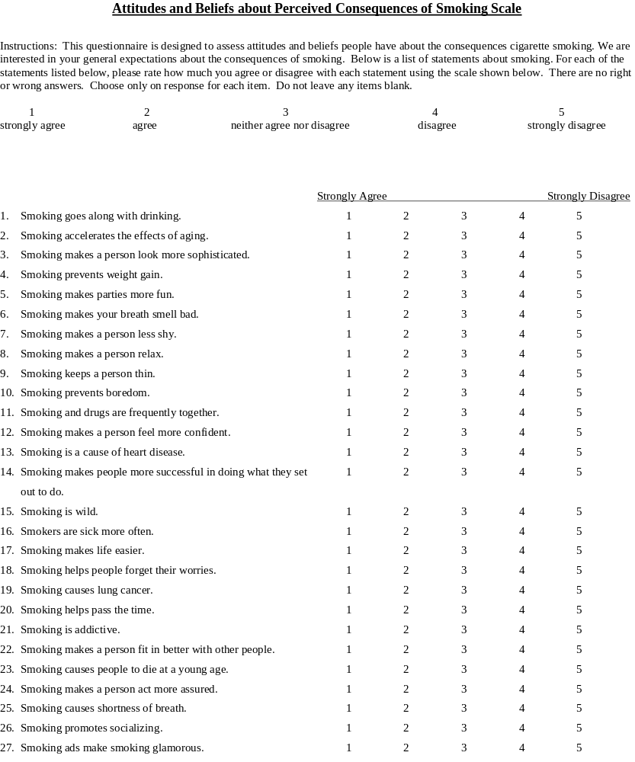

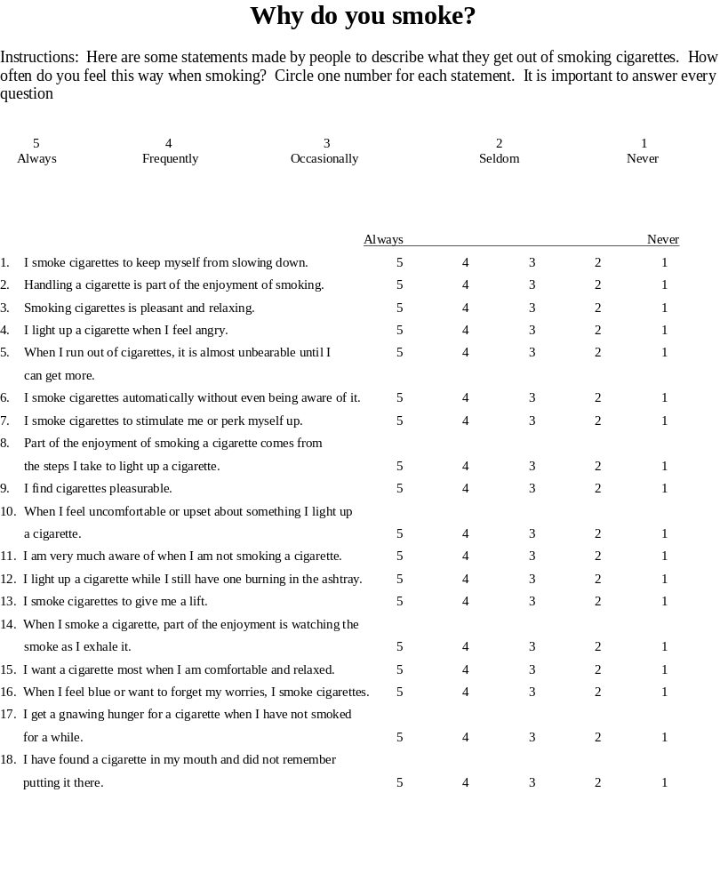
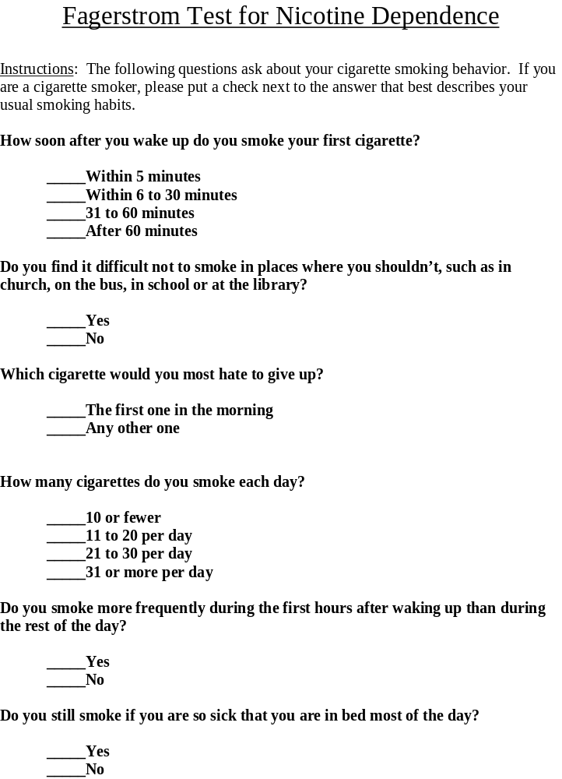

Withdrawal Symptoms Checklist (WSC)**

DIRECTIONS: Please rate (circle) the degree to which each of the following descriptive phrases applies to you AT THIS MOMENT.

 | Not Present | Mild | Moderate | Severe
1. Craving for tobacco | 0 | 1 | 2 | 3
2. Feeling irritable | 0 | 1 | 2 | 3
3. Feeling anxious | 0 | 1 | 2 | 3
4. Having difficulty concentrating | 0 | 1 | 2 | 3
5. Feeling restless | 0 | 1 | 2 | 3
6. Having a slower heartbeat | 0 | 1 | 2 | 3
7. Feeling hungry | 0 | 1 | 2 | 3
8. Feeling down/depressed | 0 | 1 | 2 | 3
9. Feeling angry | 0 | 1 | 2 | 3
10.Feeling frustrated | 0 | 1 | 2 | 3
11.Had difficulty sleeping last night | 0 | 1 | 2 | 3

**Adapted from Hughes, J.R. & Hatsukami, D.K. (1986). Signs and symptoms of tobacco withdrawal. Archives of General Psychiatry, 43, 289-294: and the American Psychiatric Association. (1994). Diagnostic and Statistical Manual of Mental Disorders. (4th ed.). Washington, DC: Author.
These individual items are not copyrighted material.

